|  |  |  |  |  |
| --- | --- | --- | --- | --- |
|  |  | | |  |
|  |  | | |  |
|  | Automatic Engine Idle Shutdown (AEIS)  <<Feature>>  (F000760) | | |  |
|  |  | | |  |
| Document Type | **Feature Document (FD)** | | |  |
| Template Version | **6.0b / FFSD 8.0** | | |  |
| SysML Report Template Version | **O (11/12/2019)** | | |  |
| Document ID | **aeis feature document_v2.2.docx** | | |  |
| Document Location |  | | |  |
| Document Owner | **CP Engelbrecht (cengelb5)** | | |  |
| Document Revision | **FD0** | | |  |
| Document Status | **Draft** | | |  |
| Date Issued | **2020-10-12** | | |  |
| Date Revised | **2020-10-12** | | |  |
| Document Classification | GIS1 Item Number: | **27.60/35** | |  |
| GIS2 Classification: | **Confidential** | |
|  | | | | |
|  | | | | |
| Document Approval | | | | |
| Person | Role | | Email Confirmation | Date |
|  |  | |  |  |
|  |  | |  |  |

**Auto-Generated by MagicDraw**

Printed Copies Are Uncontrolled

# Disclaimer

**This document contains Ford Motor Company Confidential information. Disclosure of the information contained in any portion of this document is not permitted without the expressed, written consent of a duly authorized representative of Ford Motor Company, Dearborn, Michigan, U.S.A.**

**Copyright, Ó 2016 Ford Motor Company**

This document contains information developed and accumulated by and for FORD MOTOR COMPANY. As such, it is a proprietary document, which, if disseminated to unauthorized persons, would provide others with restricted information, data, or procedures not otherwise available, exposing the FORD MOTOR COMPANY to potential harm.

Employees and suppliers having custody of this specification or authorized to use it must be cognizant of its proprietary nature and ensure that the information herein is not made available to unauthorized persons.

FORD MOTOR COMPANY reserves the right to protect this work as an unpublished copyrighted work in the event of an inadvertent or deliberate unauthorized publication. FORD MOTOR COMPANY also reserves its rights under copyright laws to protect this work as a published work.

This document or portions thereof shall not be distributed outside FORD MOTOR COMPANY without prior written consent. Refer all questions concerning disclosure to the author(s) or to any duly authorized representative of Ford Motor Company.

# Contents

Disclaimer 2

Contents 3

1 Introduction 5

1.1 Document Purpose 5

1.2 Document Scope 5

1.3 Document Audience 5

1.3.1 Stakeholder List 5

1.4 Document Organization 5

1.4.1 Document Context 5

1.4.2 Document Structure 6

1.5 Document Conventions 6

1.5.1 Requirements Templates 6

1.6 References 6

1.6.1 Ford Documents 6

1.6.2 External Documents and Publications 6

1.7 Glossary 7

1.7.1 Parameters / Values 7

2 Feature Overview 8

2.1 Purpose and Description of Feature 8

2.2 Feature Variants 8

2.2.1 Regions & Markets 9

2.3 Input Requirements 9

2.3.1 Legal Requirements 9

2.3.2 Trustmark Requirements 9

2.3.3 Industry Standards 9

2.3.4 Attribute Requirements 9

2.4 Lessons Learned 9

2.5 Assumptions 9

3 Feature Context 10

3.1 Feature Context Diagram 10

3.2 List of Influences 10

4 Feature Modeling 12

4.1 Operation Modes and States 12

4.2 Use Cases 13

4.2.1 Use Case Diagram 13

4.2.2 Actors 13

4.2.3 Use Case Descriptions 14

4.3 Driving and Operation Scenarios 17

4.4 Decision Tables 19

5 Feature Requirements 20

5.1 Functional Requirements 20

5.1.1 Error Handling 25

5.2 Non-Functional Requirements 25

5.2.1 Safety 26

5.2.2 Security 26

5.2.3 Reliability 26

5.3 HMI Requirements 26

5.4 Other Requirements 27

5.4.1 Design Requirements 27

5.4.2 Manufacturing Requirements 27

5.4.3 Service Requirements 27

5.4.4 After Sales Requirements 27

5.4.5 Process Requirements 27

6 Functional Safety 28

6.1 System Behaviors for HARA 28

6.2 Safety Assumptions 28

6.3 Safety Goals 28

6.4 Functional Safety Requirements 29

6.4.1 Derivation of Functional Safety Requirements on Assumptions 29

6.5 ASIL Decomposition of Functional Safety Requirements 29

7 Architecture 30

7.1 Functional Architecture 30

7.1.1 List of Functions 30

7.2 Logical Architecture 31

7.2.1 Logical Elements 32

7.2.2 Logical Interfaces 32

8 Open Concerns 33

9 Revision History 34

10 Appendix 35

10.1 Definitions 35

10.2 Abbreviations 35

**List of Figures**

Figure 1: Feature Image Here 8

Figure 2: Feature Context 10

Figure 3: Logical Operating Modes 12

Figure 4: Feature Use Cases 13

Figure 5: Functional Boundary Behavior 30

Figure 6: Logical Architecture 32

**List of Tables**

Table 1: Features described in this FD 5

Table 2: Ford internal Documents 6

Table 3: External documents and publications 7

Table 4: Parameters / Values used in this document *(Not supported by MagicDraw report generation)* 7

Table 5: Feature Variants 9

Table 6: Regions & Markets 9

Table 7: List of Influences 11

Table 8: Operation Modes and States on Logical Operating Modes 12

Table 9: Transitions between Operation Modes and States on Logical Operating Modes 13

Table 10: List of Actors 14

Table 11: System Behaviors for HARA 28

Table 12: Functional Safety Assumptions 28

Table 13: List of Functions 31

Table 14: Open Concerns *(Not supported by MagicDraw report generation)* 33

Table 15: Definitions used in this document 35

# Introduction

## Document Purpose

A Feature Document (FD) document specifies **what** the feature shall do and how it shall behave from customer perspective. It should also provide reasoning and background **why** we have the feature in the vehicle.

The FD also serves as an Item Definition as defined by ISO26262 for those features, which follow the Ford Functional Safety process.

To get more information about the concept of feature, function and component level abstraction refer to the [Ford RE Wiki](http://wiki.ford.com/display/RequirementsEngineering/Requirements+Engineering+for+SW+Enabled+Features). For details on the Ford Functional Safety (ISO26262) process refer to the [Ford Functional Safety Sharepoint](https://pd3.spt.ford.com/sites/GlobalFunctionalSafety/Pages/default.aspx).

## Document Scope

This Feature Document (FD) specifies the following features:

|  |  |  |  |
| --- | --- | --- | --- |
| **Feature ID** | **Feature Name** | **Owner** | **Reference** |
| F000760 | Automatic Engine Idle Shutdown (AEIS)  (Program(s): Program Here) | CP Engelbrecht (cengelb5) |  |

Table 1: Features described in this FD

## Document Audience

The FD is written by the feature owner of CP Engelbrecht (cengelb5). All Stakeholders, i.e., all people who have a valid interest in the feature should read and, if possible, review the FD. It needs to be guaranteed, that all stakeholders have access to the currently valid version of the FD.

**#Hint:** The FD template has the IP Classification “Proprietary” by default. IP Classification “Confidential” might be required in some cases, e.g. by Ford Functional Safety.

### Stakeholder List

For the latest list of stakeholder of the feature and their influence refer to <Put VSEM Link here>.

**#Hint:** Refer to [Ford RE Wiki – Stakeholder List](http://wiki.ford.com/display/RequirementsEngineering/Stakeholder+Analysis) on how to create a stakeholder list. The stakeholder list should be stored in VSEM in the pseudo folder “General Data Artifacts” of the corresponding feature.

## Document Organization

### Document Context

Refer to the [Specification Structure page](http://wiki.ford.com/display/RequirementsEngineering/Specification+templates) in the [Ford RE Wiki](http://wiki.ford.com/display/RequirementsEngineering/Requirements+Engineering+for+SW+Enabled+Features) to understand how the FD relates to other Ford Requirements Documents and Specifications.

### Document Structure

The structure of this document is explained below:

**Section 1** – Introduction how to use this document including responsibilities and requisite documents. Explains the terminology. Gives a clarification of the definitions, concepts and abbreviations used in the document.

**Section 2** – Feature Description. States briefly the background and the purpose of the feature, feature variants and corresponding regions and markets. Also includes input requirements, assumptions and constraints.

**Section 3** – Feature Context describes all external entities, which have an influence on the feature.

**Section 4** – Feature Modeling. Contains Use Case, Driving Scenarios, State Charts to describe the functional behavior of the feature.

**Section 5** – Safety. Lists System Behaviors and Safety Goals of the feature.

**Section 6** – Feature Requirements. Lists functional and non-functional requirements of the feature.

**Section 7** – Architecture. Shows the coarse architecture, which the feature requirements are deployed to. Describes the elements and the boundary of the feature as well as the decomposition and distribution of associated functions.

**Section 8** – List of Open Concerns

**Section 9** – Document Change History including a list of new or modified requirements. The requirements in this document are tagged, and this section contains different types of tables listing all, new, or changed requirements by their title and page no.

**Section 10** – Appendix

**#Hint:** All sections are mandatory, unless explicitly marked by the tag “#Classification” as “optional” or as applicable e.g. to certain domains like “Functional Safety”.

## Document Conventions

### Requirements Templates

Each requirement, use case or scenario in this specification shall follow the corresponding template given in the document template *Specification_Macros.dotm* at [RE Wiki - Specification Templates](http://wiki.ford.com/display/RequirementsEngineering/Specification+templates?src=contextnavpagetreemode).

#### Identification of requirements

#### Requirements Attributes

The templates provided by *Specification_Macros.dotm* define a list of attributes for each requirement. This helps to classify the requirement. The attributes are explained at [RE Wiki - Requirements Attributes](http://wiki.ford.com/display/RequirementsEngineering/Requirements+Attributes?src=contextnavpagetreemode).

## References

### Ford Documents

List here all Ford internal documents, which are directly related to the feature.

| **Reference** | **Title** | **Doc. ID** | **Document Location** | **Revision** |
| --- | --- | --- | --- | --- |
| Ford GIS Standard | Ford GIS Standard |  |  |  |

Table 2: Ford internal Documents

### External Documents and Publications

The list of external documents could include books, reports and online sources.

**#Hint:** You may refer to [IEEE Citation Reference](http://www.ieee.org/documents/ieeecitationref.pdf) on how to format a reference.

| **Reference** | **Document / Publication** | **Document Location** |
| --- | --- | --- |
| IEEE Std 1012-2004 IEEE Standard for Software Verification and Validation |  |  |
| ISO/IEC 19500-2:2003 | Information technology -- Open Distributed Processing -- Part 2 |  |
| UML Testing Profile (UTP), v1.2 |  |  |
| Wikipedia |  |  |

Table 3: External documents and publications

## Glossary

**#Hint**: Terms, concepts and abbreviations used in the document shall be defined and illustrated here. Note that changes to terms and/or concepts described in this section tend to cause major updates to this document.

The tables below have feature specific definitions and abbreviations. For additional, non-feature specific terms please refer to the [RE Glossary](http://wiki.ford.com/display/RequirementsEngineering/Glossary?src=contextnavpagetreemode)

See Appendix for Definitions and Abbreviations.

### Parameters / Values

| **Name** | **Description** | **Range / Resolution** |
| --- | --- | --- |
|  |  |  |

Table 4: Parameters / Values used in this document *(Not supported by MagicDraw report generation)*

# Feature Overview

## Purpose and Description of Feature

**#Hint:** Some descriptive text to explain the purpose and functionality of the feature.

The purpose of Automatic Engine Idle Shutdown (AEIS) is to shutdown the Powerpack and Ignition when the vehicle has been left running and the system does not detect any "Intent to Drive" for a specified amount of time.

AEIS will also power down the vehicle electrical system, as if the operator had turned off the engine and removed the key. All other systems/ECUs will powerdown as per their own requirements.

The feature is intended for keyless vehicles only

Fleet Idle Shutdown and its interactions will be decribed in a seperate document.

It is possible for the driver to disable the feature for a single drive cycle through the vehicle settings.

The feature can also be disabled in the event of certain external influences that require the vehicle to remain on for extended and interrupted periods.

In the context of AEIS, no "Intent to Drive" is defined as there being no driver interaction with the pedals and the drivetrain is disengaged.

Any usage of the term 'BCM' will be construed to mean or include any Control Module of similar functionality

Any usage of the term 'Engine' shall be construed to mean or include any relevant Powerpacks with regards to HEV/BEV Applications.

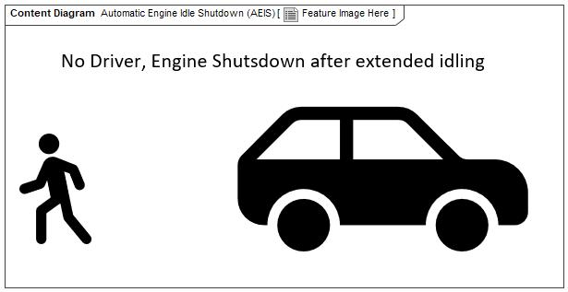

Figure 1: Feature Image Here

## Feature Variants

**#Hint:** Definitions for different variants of the feature (if applicable). Give each variant a descriptive name by which it can be referenced further on in the document. If no variant exists, state “No Feature Variants”.

The Variant Description should give a short informative text which describes the variants of the feature.

|  |  |  |
| --- | --- | --- |
| **Variant Name** | **Variant Description** | **Remarks** |
| **Keyless** |  |  |

Table 5: Feature Variants

### Regions & Markets

**#Hint:** Description of purpose and functionality of the feature. If there is no variant, give feature name in first column.

|  |  |  |  |  |  |  |
| --- | --- | --- | --- | --- | --- | --- |
| **Market /**  **Region**  Variant Name | **North America** | **South America** | **Europe** | **Middle East/Africa** | **Asia / Pacific** | **China** |
| **Keyless** | Mandatory | Mandatory | Mandatory | Mandatory | Mandatory | Mandatory |

Table 6: Regions & Markets

## Input Requirements

**#Hint:** List all input requirements, which are relevant for the feature. Typically, attribute requirements, legal requirements as well as national and international standards have to be considered.

### Legal Requirements

No Legal Requirements specified.

### Trustmark Requirements

* : Trustmark
  + Potential Trustmark status is currently under review

### Industry Standards

* : ISO 26262
  + The system should be developed according to Ford's implementation of Functional Safety.

### Attribute Requirements

* 14 : Example AR
* Proj-AR:14 : Example AR

## Lessons Learned

**#Hint:** Additional information and lessons learned from previous development or related features. A typical source for Lessons Learned is the FMA Quality History.

**#Functional Safety:** In context of Functional Safety Lessons Learned and similar information will be used to check the completeness of the Functional Safety Goals and assumptions in the Hazard Analysis and Risk Assessment (HARA).

**#Link:** [Ford Functional Safety Sharepoint](https://pd3.spt.ford.com/sites/GlobalFunctionalSafety/Pages/default.aspx)

1. Text used in the Vehicle Owner's Manual needs to be consitent
2. There have been issues with the method used for configuring the IPC and BCM to know that AEIS should be enabled. Each module being configured separately takes time and if one is configured incorrectly then AEIS will not work

## Assumptions

**#Classification**: Optional

**#Hint:** A list of known assumptions concerning the effects of the feature’s behavior on other features or elements (i.e., dependencies) as well as assumptions on the behavior expected by the feature (e.g. known limitations). During the course of the feature development most of those assumptions are typically either converted into actual requirements or discarded at some point – such that this chapter remains mostly empty. For assumptions, which are relevant for the Functional Safety process refer to chapter 6.2 “Safety Assumptions”

No Assumptions specified.

# Feature Context

## Feature Context Diagram

**#Hint:** High level diagram of feature interactions with the environment, people or other feature or other external entities.

**#Link:** [RE Wiki - Context Diagram](http://wiki.ford.com/pages/viewpage.action?pageId=107676234&src=contextnavpagetreemode)

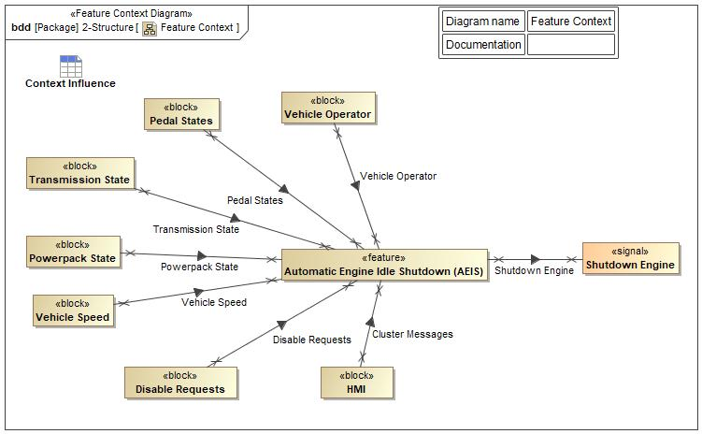

Figure 2: Feature Context

## List of Influences

|  |  |  |
| --- | --- | --- |
| **ID** | **External Entity** | **Influence Description** |
| Cluster Messages | HMI To Automatic Engine Idle Shutdown (AEIS) |  |
| Disable Requests | Disable Requests To Automatic Engine Idle Shutdown (AEIS) |  |
| Pedal States | Pedal States To Automatic Engine Idle Shutdown (AEIS) |  |
| Powerpack State | Powerpack State To Automatic Engine Idle Shutdown (AEIS) |  |
| Shutdown Engine | Automatic Engine Idle Shutdown (AEIS) To |  |
| Transmission State | Transmission State To Automatic Engine Idle Shutdown (AEIS) |  |
| Vehicle Operator | Vehicle Operator To Automatic Engine Idle Shutdown (AEIS) |  |
| Vehicle Speed | Vehicle Speed To Automatic Engine Idle Shutdown (AEIS) |  |

Table 7: List of Influences

# Feature Modeling

## Operation Modes and States

**#Classification:** Optional (Mandatory for Functional Safety)

**#Link:** [RE Wiki – State Charts](http://wiki.ford.com/display/RequirementsEngineering/State+Charts?src=contextnavpagetreemode)

**#Hint:** State Charts are a popular means to express feature behavior in terms of states and modes. An advantage of this state machine like approach is that consistency can be easily verified.

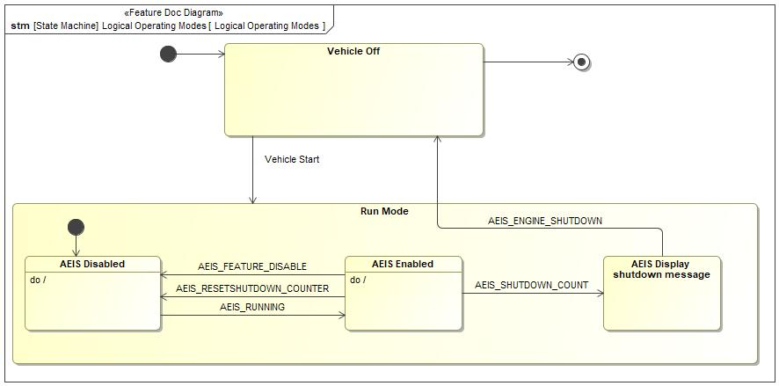

Figure 3: Logical Operating Modes

|  |  |  |
| --- | --- | --- |
| **State** | **Description** | **Requirements Reference** (optional) |
| AEIS Disabled | AEIS Feature has been disabled by any one of the disabling conditions. The Vehicle will NOT shutdown through AEIS. |  |
| AEIS Display shutdown message | Timer has reached shutdown time minus 30 seconds. signal sent to cluster to show shutdown message |  |
| AEIS Enabled | No disabling conditions are TRUE so AEIS timer is active and will shutdown the Engine when it reaches max count. |  |
| Run Mode | Vehicle is in a state where it can be driven.  This includes Engine On for vehicles with an engine and Drive Ready for HEV/BEVs |  |
| Vehicle Off | Vehicle is in an OFF state, where it cannot be driven. |  |

Table 8: Operation Modes and States on Logical Operating Modes

|  |  |  |
| --- | --- | --- |
| **Transition ID** | **Description** | **Requirements Reference**  (optional) |
| T1 |  |  |
| T2 | Trigger signal: Vehicle Start |  |
| T3 | Name: Engine Shutdown  Trigger signal: AEIS_ENGINE_SHUTDOWN |  |
| T4 | Trigger signal: AEIS_RESETSHUTDOWN_COUNTER |  |
| T5 |  |  |
| T6 | Trigger signal: AEIS_SHUTDOWN_COUNT |  |
| T7 | Guard: =  Trigger signal: AEIS_FEATURE_DISABLE |  |
| T8 | Trigger signal: AEIS_RUNNING |  |
| T9 |  |  |

Table 9: Transitions between Operation Modes and States on Logical Operating Modes

## Use Cases

**#Classification:** Optional

**#Link:** [RE Wiki – Use Cases](http://wiki.ford.com/display/RequirementsEngineering/Use+Cases+Overview?src=contextnavpagetreemodehttp://wiki.ford.com/display/RequirementsEngineering/Use+Cases?src=contextnavpagetreemode)

### Use Case Diagram

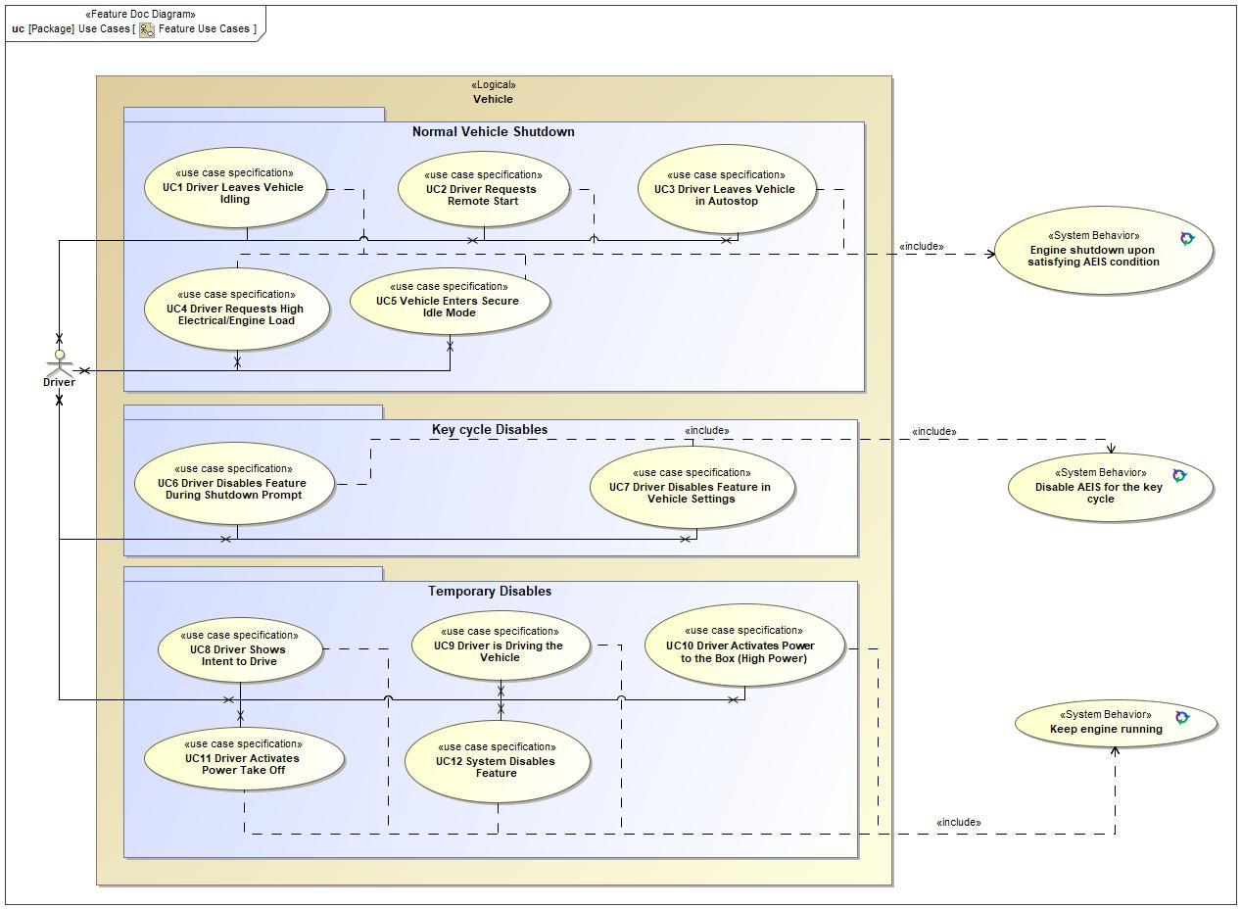

Figure 4: Feature Use Cases

### Actors

| **Actor** | **Description** |
| --- | --- |
| Driver | Actor description on Documentation field. |

Table 10: List of Actors

### Use Case Descriptions

**#Classification:** Optional

UC1 Driver Leaves Vehicle Idling

|  |  |  |
| --- | --- | --- |
| **Actors** |  | Driver |
| **Description** |  |  |
| **Preconditions** | PreC1 | AEIS is not disabled |
| PreC2 | Engine is running |
| **Triggers** | T1 | Vehicle is stationary |
| **Main Flow Description** |  | Vehicle successfully shutsdown after a specified time of no user interaction |
| **Main Flow** | M1 | Driver does not indicate any intent to drive |
| M2 | After specified time elapses, message appears on cluster informing of impending shutdown |
| M3 | Driver takes no action within specified time |
| M4 | Vehicle shutsdown |
| **Postconditions** | PostC1 | The Driver can restart the vehicle and engine restarts smoothly |

UC2 Driver Requests Remote Start

|  |  |  |
| --- | --- | --- |
| **Actors** |  | Driver |
| **Description** |  |  |
| **Preconditions** | PreC1 | Vehicle is stationary |
| **Triggers** | T1 | Vehicle is started Remotely |
| **Main Flow Description** |  | Vehicle successfully shutsdown after a specified time of no user interaction |
| **Main Flow** | M1 | Vehicle is left unattended for specified time |
| M2 | Vehicle shutsdown |

UC3 Driver Leaves Vehicle in Autostop

|  |  |  |
| --- | --- | --- |
| **Actors** |  | Driver |
| **Description** |  |  |
| **Preconditions** | PreC1 | Vehicle enters Autostop condition |
| **Main Flow Description** |  | Vehicle successfully shutsdown after a specified time of no user interaction |
| **Main Flow** | M1 | Driver does not interact with the vehicle any further |
| M2 | After specified time elapses, message appears on cluster informing of impending shutdown |
| M3 | Vehicle shutsdown |

UC4 Driver Requests High Electrical/Engine Load

|  |  |  |
| --- | --- | --- |
| **Actors** |  | Driver |
| **Description** |  |  |
| **Preconditions** | PreC1 | AEIS is not disabled |
| PreC2 | Engine is running |
| PreC3 | Vehicle is stationary |
| **Triggers** | T1 | A/C enters high load state |
| T2 | Front/back Heated screens are enabled |
| T3 | Heated seats/steering wheel are enabled |
| **Main Flow Description** |  | Vehicle successfully shutsdown after a specified time of no user interaction |
| **Main Flow** | M1 | Driver does not interact with the vehicle any further |
| M2 | After specified time elapses, message appears on cluster informing of impending shutdown |
| M3 | Vehicle shutsdown |

UC5 Vehicle Enters Secure Idle Mode

|  |  |  |
| --- | --- | --- |
| **Actors** |  | Driver |
| **Description** |  |  |
| **Preconditions** | PreC1 | AEIS is not disabled |
| PreC2 | Engine is running |
| PreC3 | Vehicle is stationary |
| **Triggers** | T1 | Driver Leaves Vehicle Idling |
| **Main Flow Description** |  | Vehicle successfully shutsdown after a specified time of no user interaction |
| **Main Flow** | M1 | Driver leaves the vehicle and locks the doors |
| M2 | After specified time elapses, message appears on cluster informing of impending shutdown |
| M3 | Vehicle shutsdown |

UC6 Driver Disables Feature During Shutdown Prompt

|  |  |  |
| --- | --- | --- |
| **Actors** |  | Driver |
| **Description** |  |  |
| **Preconditions** | PreC1 | AEIS is not disabled |
| PreC2 | Engine is running |
| PreC3 | Vehicle is stationary |
| **Triggers** | T1 | Vehicle shutdown is imminent |
| **Main Flow Description** |  | Vehicle does not shutdown automatically for that keycycle |
| **Main Flow** | M1 | Driver does not indicate any intent to drive |
| M2 | After specified time elapses, message appears on cluster informing of impending shutdown |
| M3 | Driver chooses option to keep engine running |
| M4 | There is no Engine Shutdown after 30 minutes |

UC7 Driver Disables Feature in Vehicle Settings

|  |  |  |
| --- | --- | --- |
| **Actors** |  | Driver |
| **Description** |  |  |
| **Preconditions** | PreC1 | AEIS is not disabled |
| **Triggers** | T1 | Vehicle is on |
| **Main Flow Description** |  | Vehicle does not shutdown automatically for that keycycle |
| **Main Flow** | M1 | Driver navigates through vehicle settings and chooses to disable Feature |
| M2 | Engine stays on |
| **Postconditions** | PostC1 | After a key cycle the Feature is automatically re-enabled |

UC8 Driver Shows Intent to Drive

|  |  |  |
| --- | --- | --- |
| **Actors** |  | Driver |
| **Description** |  |  |
| **Preconditions** | PreC1 | AEIS is not disabled |
| PreC2 | Engine is running |
| PreC3 | Vehicle is stationary |
| **Triggers** | T1 | Driver presses Brake pedal or |
| T2 | Driver presses Clutch pedal or |
| T3 | Driver presses Accelerator pedal or |
| T4 | Driver puts transmission in Drive |
| **Main Flow Description** |  | Vehicle does not shutdown automatically while Intent to Drive is being shown |
| **Main Flow** | M1 | Driver shows intent to drive |
| M2 | Engine stays on |

UC9 Driver is Driving the Vehicle

|  |  |  |
| --- | --- | --- |
| **Actors** |  | Driver |
| **Description** |  |  |
| **Preconditions** |  |  |
| **Triggers** | T1 | Vehicle Speed is above "Stationary" limit |
| **Main Flow Description** |  | Vehicle does not shutdown automatically while in motion |
| **Main Flow** | M1 | Engine stays on |

UC10 Driver Activates Power to the Box (High Power)

|  |  |  |
| --- | --- | --- |
| **Actors** |  | Driver |
| **Description** |  |  |
| **Preconditions** | PreC1 | AEIS is not disabled |
| PreC2 | Engine is running |
| PreC3 | Vehicle is stationary |
| **Triggers** | T1 | Power to the Box High Power Mode is Activated |
| **Main Flow Description** |  | Vehicle does not shutdown automatically while PttB is active |
| **Main Flow** | M1 | Engine stays on |

UC11 Driver Activates Power Take Off

|  |  |  |
| --- | --- | --- |
| **Actors** |  | Driver |
| **Description** |  |  |
| **Preconditions** | PreC1 | AEIS is not disabled |
| PreC2 | Engine is running |
| PreC3 | Vehicle is stationary |
| **Triggers** | T1 | Power Take Off is Activated |
| **Main Flow Description** |  | Vehicle does not shutdown automatically while in PTO is active |
| **Main Flow** | M1 | Engine stays on |

UC12 System Disables Feature

|  |  |  |
| --- | --- | --- |
| **Actors** |  | Driver |
| **Description** |  |  |
| **Preconditions** | PreC1 | AEIS is not disabled |
| PreC2 | Engine is running |
| **Triggers** | T1 | Input Signal Fault is Detected |
| T2 | DPF Regen Requested or |
| **Main Flow Description** |  | Vehicle does not shutdown automatically while in Particulate Filter Regen is active  or  an Input Signal Fault is detected |
| **Main Flow** | M1 | Engine stays on |

## Driving and Operation Scenarios

**#Classification:** Optional (Mandatory for Functional Safety)

**#Functional Safety:** Driving and operating scenarios which impact the functionality of the feature can be used to check, if the situation analysis in the HARA is complete

**#Link:** [RE Wiki – Driving Scenarios](http://wiki.ford.com/display/RequirementsEngineering/Driving+Scenarios?src=contextnavpagetreemode)

Generic Feature Scenario

Description of the scenario in the Documentation field on the Feature Scenario Diagram.

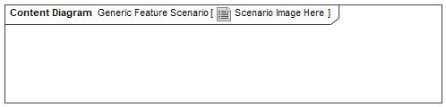

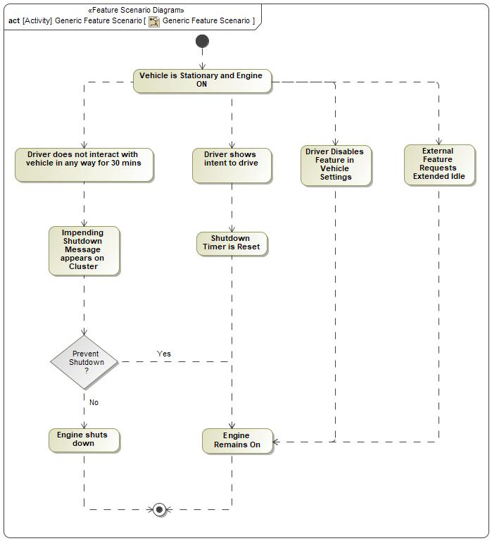

|  |  |
| --- | --- |
| **Flow of Actions** | |
| 1 | Vehicle is Stationary and Engine ON |
| 2 | Driver shows intent to drive |
| 3 | Shutdown Timer is Reset |
| 4 | Engine Remains On |
| 5 | Driver does not interact with vehicle in any way for 30 mins |
| 6 | Impending Shutdown Message appears on Cluster |
| 7 | External Feature Requests Extended Idle |
| 8 | Driver Disables Feature in Vehicle Settings |

## Decision Tables

**#Classification:** Optional

**#Link:** [RE Wiki – Decision Tables](http://wiki.ford.com/display/RequirementsEngineering/Decision+Table).

**#Hint:** Use decision table, if behavior is not state based (in that case prefer state chart from ch. 4.1) and based purely on current inputs.

*Not supported by MagicDraw report generation.*

# Feature Requirements

**#Functional Safety:** In general, safety requirements are not listed here. However, it is possible that later in the development process, a non-safety requirement becomes a safety requirement. In such a case it may remain on this list.

**#Link:** [RE Wiki – How to write good requirements](http://wiki.ford.com/display/RequirementsEngineering/How+to+write+better+requirements?src=contextnavpagetreemode).

## Functional Requirements

REQ-397064/A Auto Engine Idle Shutdown (AEIS)

a) The Feature shall detect an extended idle condition and automatically shutdown the engine after a calibratable time (up to 3600 seconds).

b) The feature shall notify the Driver Information Display 30 seconds before automatic shutdown will occur.

c) The ‘BCM’ shall be continuously notified when the automatic shutdown has completed.

|  |  |  |  |  |  |  |  |
| --- | --- | --- | --- | --- | --- | --- | --- |
| Requirement ID: REQ-397064/A | | | | | | | |
| **Rationale** | To automatically shutdown the engine when it is left running unattended to save fuel. | | | | | | |
| **Acceptance Criteria** | Engine has successfully shutdown | | | | | | |
| **Notes** |  | | | | | | |
| **Source** |  | | | | | **Owner** |  |
| **Source Req.** |  | | | | | **V&V Method** |  |
| **Type** |  | | | **Priority** |  | **Status** |  |
| [Req. Template](http://wiki.ford.com/display/RequirementsEngineering/Requirements+Attributes) Version | | 6.0 | End of Requirement | | | | |

REQ-397756/A Key type enablement of AEIS

The System shall detect if the key type is Push Button/Passive Start and the Feature shall be enabled.

|  |  |  |  |  |  |  |  |
| --- | --- | --- | --- | --- | --- | --- | --- |
| Requirement ID: REQ-397756/A | | | | | | | |
| **Rationale** | To not execute the feature if the vehicle key configuration is not the type calibrated to use AEIS. | | | | | | |
| **Acceptance Criteria** |  | | | | | | |
| **Notes** |  | | | | | | |
| **Source** |  | | | | | **Owner** |  |
| **Source Req.** |  | | | | | **V&V Method** |  |
| **Type** |  | | | **Priority** |  | **Status** |  |
| [Req. Template](http://wiki.ford.com/display/RequirementsEngineering/Requirements+Attributes) Version | | 6.0 | End of Requirement | | | | |

REQ-397757/A Shutoff Electrical Loads

The ‘BCM’ shall power down the vehicle electrical systems after the Feature has shutdown the engine.

|  |  |  |  |  |  |  |  |
| --- | --- | --- | --- | --- | --- | --- | --- |
| Requirement ID: REQ-397757/A | | | | | | | |
| **Rationale** | To shutoff the vehicle power when AEIS shuts off the engine to save the battery charge. | | | | | | |
| **Acceptance Criteria** |  | | | | | | |
| **Notes** |  | | | | | | |
| **Source** |  | | | | | **Owner** |  |
| **Source Req.** |  | | | | | **V&V Method** |  |
| **Type** |  | | | **Priority** |  | **Status** |  |
| [Req. Template](http://wiki.ford.com/display/RequirementsEngineering/Requirements+Attributes) Version | | 6.0 | End of Requirement | | | | |

REQ-397758/A Determine shutdown entry conditions

The Feature shall be enabled when no "Driver Presence" and no "Intent to Drive" conditions are met.

This is defined as there being no Pedal Inputs, Transmission is in Park/Neutral, Ignition is “ON”, and Vehicle is stationary. When these conditions are not met, the Feature shall be disabled.

|  |  |  |  |  |  |  |  |
| --- | --- | --- | --- | --- | --- | --- | --- |
| Requirement ID: REQ-397758/A | | | | | | | |
| **Rationale** | To determine when the vehicle is stationary and inferred to be unintended. | | | | | | |
| **Acceptance Criteria** |  | | | | | | |
| **Notes** |  | | | | | | |
| **Source** |  | | | | | **Owner** |  |
| **Source Req.** |  | | | | | **V&V Method** |  |
| **Type** |  | | | **Priority** |  | **Status** | In-Progress |
| [Req. Template](http://wiki.ford.com/display/RequirementsEngineering/Requirements+Attributes) Version | | 6.0 | End of Requirement | | | | |

REQ-397759/A Initialize AEIS feature

The Feature shall initialize after engine start, shall not inhibit engine start and the shutdown timer shall be reset to zero.

|  |  |  |  |  |  |  |  |
| --- | --- | --- | --- | --- | --- | --- | --- |
| Requirement ID: REQ-397759/A | | | | | | | |
| **Rationale** | To schedule when the AEIS feature shall be initialized | | | | | | |
| **Acceptance Criteria** |  | | | | | | |
| **Notes** |  | | | | | | |
| **Source** |  | | | | | **Owner** |  |
| **Source Req.** |  | | | | | **V&V Method** |  |
| **Type** |  | | | **Priority** |  | **Status** | In-Progress |
| [Req. Template](http://wiki.ford.com/display/RequirementsEngineering/Requirements+Attributes) Version | | 6.0 | End of Requirement | | | | |

REQ-397761/A Inhibit AEIS due to input fault

The Feature shall be inhibited when any of the following inputs are faulted.

Brake Pedal Position, Clutch Pedal Position, Accelerator Pedal Position, Vehicle Speed, Transmission Shift Lever.

|  |  |  |  |  |  |  |  |
| --- | --- | --- | --- | --- | --- | --- | --- |
| Requirement ID: REQ-397761/A | | | | | | | |
| **Rationale** | It allows the feature to be disabled in the event of an input fault which would prevent the feature from operating reliably. | | | | | | |
| **Acceptance Criteria** |  | | | | | | |
| **Notes** |  | | | | | | |
| **Source** |  | | | | | **Owner** |  |
| **Source Req.** |  | | | | | **V&V Method** |  |
| **Type** |  | | | **Priority** |  | **Status** | In-Progress |
| [Req. Template](http://wiki.ford.com/display/RequirementsEngineering/Requirements+Attributes) Version | | 6.0 | End of Requirement | | | | |

REQ-397762/A Inhibit AEIS when DPF Regen is active

The Feature will be inhibited when DPF service regeneration is running in order to prevent interrupting the DPF regeneration.

|  |  |  |  |  |  |  |  |
| --- | --- | --- | --- | --- | --- | --- | --- |
| Requirement ID: REQ-397762/A | | | | | | | |
| **Rationale** | To prevent interrupting the DPF regeneration | | | | | | |
| **Acceptance Criteria** |  | | | | | | |
| **Notes** |  | | | | | | |
| **Source** |  | | | | | **Owner** |  |
| **Source Req.** |  | | | | | **V&V Method** |  |
| **Type** |  | | | **Priority** |  | **Status** | Approved |
| [Req. Template](http://wiki.ford.com/display/RequirementsEngineering/Requirements+Attributes) Version | | 6.0 | End of Requirement | | | | |

REQ-397763/A Start AEIS feature

The Feature shall be enabled when the power pack status indicates the vehicle is only in ‘Run Mode’.

‘Run Mode’ includes engine pull up/pull down events, Stop/Start and BEV.

|  |  |  |  |  |  |  |  |
| --- | --- | --- | --- | --- | --- | --- | --- |
| Requirement ID: REQ-397763/A | | | | | | | |
| **Rationale** | To actively monitor the entry conditions for the AEIS feature once the engine is running. | | | | | | |
| **Acceptance Criteria** |  | | | | | | |
| **Notes** |  | | | | | | |
| **Source** |  | | | | | **Owner** |  |
| **Source Req.** |  | | | | | **V&V Method** |  |
| **Type** |  | | | **Priority** |  | **Status** | In-Progress |
| [Req. Template](http://wiki.ford.com/display/RequirementsEngineering/Requirements+Attributes) Version | | 6.0 | End of Requirement | | | | |

REQ-397764/A Shutdown timer mode

The Feature shall increment a timer in seconds starting from zero while all enable conditions are met.

|  |  |  |  |  |  |  |  |
| --- | --- | --- | --- | --- | --- | --- | --- |
| Requirement ID: REQ-397764/A | | | | | | | |
| **Rationale** | To start to track the time since the vehicle has met the stationary and unattended requirements. This is the start of the automatic engine idle shutdown process. | | | | | | |
| **Acceptance Criteria** |  | | | | | | |
| **Notes** |  | | | | | | |
| **Source** |  | | | | | **Owner** |  |
| **Source Req.** |  | | | | | **V&V Method** |  |
| **Type** |  | | | **Priority** |  | **Status** | In-Progress |
| [Req. Template](http://wiki.ford.com/display/RequirementsEngineering/Requirements+Attributes) Version | | 6.0 | End of Requirement | | | | |

REQ-397765/A Request Engine Shutdown

The Feature shall request an automatic engine shutdown when the timer exceeds the calibratable shutdown time.

|  |  |  |  |  |  |  |  |
| --- | --- | --- | --- | --- | --- | --- | --- |
| Requirement ID: REQ-397765/A | | | | | | | |
| **Rationale** | To indicate to other engine features that an engine shutdown shall occur when the allowed unattended idle time is reached. | | | | | | |
| **Acceptance Criteria** |  | | | | | | |
| **Notes** |  | | | | | | |
| **Source** |  | | | | | **Owner** |  |
| **Source Req.** |  | | | | | **V&V Method** |  |
| **Type** |  | | | **Priority** |  | **Status** | In-Progress |
| [Req. Template](http://wiki.ford.com/display/RequirementsEngineering/Requirements+Attributes) Version | | 6.0 | End of Requirement | | | | |

REQ-397766/A Track shutdown time

The shutdown time shall be tracked in seconds. It shall start/initialize at zero and increment when the feature entry conditions are met.

|  |  |  |  |  |  |  |  |
| --- | --- | --- | --- | --- | --- | --- | --- |
| Requirement ID: REQ-397766/A | | | | | | | |
| **Rationale** | To track the time that the AEIS shutdown entry conditions have been met. | | | | | | |
| **Acceptance Criteria** |  | | | | | | |
| **Notes** |  | | | | | | |
| **Source** |  | | | | | **Owner** |  |
| **Source Req.** |  | | | | | **V&V Method** |  |
| **Type** |  | | | **Priority** |  | **Status** | In-Progress |
| [Req. Template](http://wiki.ford.com/display/RequirementsEngineering/Requirements+Attributes) Version | | 6.0 | End of Requirement | | | | |

REQ-397767/A Timer reset

The timer shall reset to the initialization value of zero when the Feature is initialized, temporarily disabled, permanently disabled, or enable conditions are no longer met.

|  |  |  |  |  |  |  |  |
| --- | --- | --- | --- | --- | --- | --- | --- |
| Requirement ID: REQ-397767/A | | | | | | | |
| **Rationale** | To clear the shutdown conditions. | | | | | | |
| **Acceptance Criteria** |  | | | | | | |
| **Notes** |  | | | | | | |
| **Source** |  | | | | | **Owner** |  |
| **Source Req.** |  | | | | | **V&V Method** |  |
| **Type** |  | | | **Priority** |  | **Status** | In-Progress |
| [Req. Template](http://wiki.ford.com/display/RequirementsEngineering/Requirements+Attributes) Version | | 6.0 | End of Requirement | | | | |

REQ-397768/A Shutdown Engine

The engine shall shutdown when the AEIS feature requests a shutdown. The shutdown shall be conducted in the same manner as a customer key-off and shall require a key cycle to restart. When the engine shutdown is complete a signal must be sent to indicate the engine was shutdown. The CAN communication must continue a calibratable time after the engine shutdown to notify the ‘BCM’ (typically 60 seconds).

|  |  |  |  |  |  |  |  |
| --- | --- | --- | --- | --- | --- | --- | --- |
| Requirement ID: REQ-397768/A | | | | | | | |
| **Rationale** | To coordinate the automatic engine shutdown sequence of shutting down the engine, blocking an engine restart until key is cycled, notifying AEIS that the engine shutdown is complete (engine has stopped), and keeping the engine control unit CAN communication "awake" to notify other modules that the shutdown occurred. | | | | | | |
| **Acceptance Criteria** |  | | | | | | |
| **Notes** |  | | | | | | |
| **Source** |  | | | | | **Owner** |  |
| **Source Req.** |  | | | | | **V&V Method** |  |
| **Type** |  | | | **Priority** |  | **Status** | In-Progress |
| [Req. Template](http://wiki.ford.com/display/RequirementsEngineering/Requirements+Attributes) Version | | 6.0 | End of Requirement | | | | |

REQ-397769/A Start blocking

The Feature shall request the starter motor control to block a crank event, forcing a key cycle to restart the engine after an AEIS requested shutdown.

|  |  |  |  |  |  |  |  |
| --- | --- | --- | --- | --- | --- | --- | --- |
| Requirement ID: REQ-397769/A | | | | | | | |
| **Rationale** | To prevent the customer from re-cranking the engine after an automatic engine idle shutdown which might prevent some engine features from initializing as intended. This will force the customer to cycle the key off then back to the run/crank position. | | | | | | |
| **Acceptance Criteria** |  | | | | | | |
| **Notes** |  | | | | | | |
| **Source** |  | | | | | **Owner** |  |
| **Source Req.** |  | | | | | **V&V Method** |  |
| **Type** |  | | | **Priority** |  | **Status** | In-Progress |
| [Req. Template](http://wiki.ford.com/display/RequirementsEngineering/Requirements+Attributes) Version | | 6.0 | End of Requirement | | | | |

REQ-397770/A Send Shutdown State

The Feature shall send a continuous CAN message to the Driver Information Display and ‘BCM’ indicating whether the feature is in the following states:

“normal state” - The Feature is disabled or more than 30 seconds away from shutting down.

“shutdown imminent” - 30 seconds before and until shutdown.

“shutdown occurred” - The engine has successfully shutdown.

|  |  |  |  |  |  |  |  |
| --- | --- | --- | --- | --- | --- | --- | --- |
| Requirement ID: REQ-397770/A | | | | | | | |
| **Rationale** | To encode the AEIS operating states into the necessary CAN communication signals to the cluster and body control module / load shed device. | | | | | | |
| **Acceptance Criteria** |  | | | | | | |
| **Notes** |  | | | | | | |
| **Source** |  | | | | | **Owner** |  |
| **Source Req.** |  | | | | | **V&V Method** |  |
| **Type** |  | | | **Priority** |  | **Status** | In-Progress |
| [Req. Template](http://wiki.ford.com/display/RequirementsEngineering/Requirements+Attributes) Version | | 6.0 | End of Requirement | | | | |

REQ-397771/A Inhibit AEIS for OSC Channel

The Feature shall be inhibited when the AEIS OSC channel is active.

|  |  |  |  |  |  |  |  |
| --- | --- | --- | --- | --- | --- | --- | --- |
| Requirement ID: REQ-397771/A | | | | | | | |
| **Rationale** | Allow a technician to perform maintenance that requires a vehicle to idle longer than the AEIS shutdown time | | | | | | |
| **Acceptance Criteria** |  | | | | | | |
| **Notes** |  | | | | | | |
| **Source** |  | | | | | **Owner** |  |
| **Source Req.** |  | | | | | **V&V Method** |  |
| **Type** |  | | | **Priority** |  | **Status** | In-Progress |
| [Req. Template](http://wiki.ford.com/display/RequirementsEngineering/Requirements+Attributes) Version | | 6.0 | End of Requirement | | | | |

REQ-397772/A Inhibit AEIS for Eco Inhibit

The Feature shall be inhibited when Eco Inhibit is active.

(see Eco Inhibit requirements for details)

|  |  |  |  |  |  |  |  |
| --- | --- | --- | --- | --- | --- | --- | --- |
| Requirement ID: REQ-397772/A | | | | | | | |
| **Rationale** | EcoInhibit disables various eco-related functions such as Stop/Start, SRC and AEIS.  Eco Inhibit is typically enabled on commercial vehicles, such as an ambulance, that require uninterrupted engine idle. | | | | | | |
| **Acceptance Criteria** |  | | | | | | |
| **Notes** |  | | | | | | |
| **Source** |  | | | | | **Owner** |  |
| **Source Req.** |  | | | | | **V&V Method** |  |
| **Type** |  | | | **Priority** |  | **Status** | In-Progress |
| [Req. Template](http://wiki.ford.com/display/RequirementsEngineering/Requirements+Attributes) Version | | 6.0 | End of Requirement | | | | |

REQ-397773/A Inhibit AEIS for Power to the Box

The Feature shall be inhibited when the Power-to-the-Box (PttB) feature is in High Power mode.

|  |  |  |  |  |  |  |  |
| --- | --- | --- | --- | --- | --- | --- | --- |
| Requirement ID: REQ-397773/A | | | | | | | |
| **Rationale** | High power mode may be used for long periods of time when the vehicle is parked. It is undesirable for AEIS to interrupt PttB by shutting down the vehicle after 30 minutes.  This is a convenience feature. The customer must push a button to enable “High Power Mode”, which inhibits AEIS and provides uninterrupted use of PttB. | | | | | | |
| **Acceptance Criteria** |  | | | | | | |
| **Notes** |  | | | | | | |
| **Source** |  | | | | | **Owner** |  |
| **Source Req.** |  | | | | | **V&V Method** |  |
| **Type** |  | | | **Priority** |  | **Status** | In-Progress |
| [Req. Template](http://wiki.ford.com/display/RequirementsEngineering/Requirements+Attributes) Version | | 6.0 | End of Requirement | | | | |

REQ-397774/A Enable AEIS for Power to the Box Low Fuel

The Feature shall be enabled when the Power-to-the-Box (PttB) feature is in High Power and low fuel mode.

For Keyed AND Keyless

|  |  |  |  |  |  |  |  |
| --- | --- | --- | --- | --- | --- | --- | --- |
| Requirement ID: REQ-397774/A | | | | | | | |
| **Rationale** | Enable AEIS feature when vehicle is in High Power mode (using PTTB) but in Low Fuel mode. This requirement is taking into account that user might leave vehicle unattended while using PTTB and fuel runs low. | | | | | | |
| **Acceptance Criteria** |  | | | | | | |
| **Notes** |  | | | | | | |
| **Source** |  | | | | | **Owner** |  |
| **Source Req.** |  | | | | | **V&V Method** |  |
| **Type** |  | | | **Priority** |  | **Status** | In-Progress |
| [Req. Template](http://wiki.ford.com/display/RequirementsEngineering/Requirements+Attributes) Version | | 6.0 | End of Requirement | | | | |

REQ-397775/A AEIS configuration mis-match DTC

The System shall ensure that the Driver Information Display is correctly configured for AEIS.

If the CAN signal from the Driver Information Display says the feature is disabled at start up and it is keyless, then a DTC shall be set.

|  |  |  |  |  |  |  |  |
| --- | --- | --- | --- | --- | --- | --- | --- |
| Requirement ID: REQ-397775/A | | | | | | | |
| **Rationale** | This ensures that a mis-configured IPC will not disable AEIS on a keyless vehicle. | | | | | | |
| **Acceptance Criteria** |  | | | | | | |
| **Notes** |  | | | | | | |
| **Source** |  | | | | | **Owner** |  |
| **Source Req.** |  | | | | | **V&V Method** |  |
| **Type** |  | | | **Priority** |  | **Status** | In-Progress |
| [Req. Template](http://wiki.ford.com/display/RequirementsEngineering/Requirements+Attributes) Version | | 6.0 | End of Requirement | | | | |

REQ-397776/A Write DID information

The Feature shall require a DID to track the following information:

• The number of times the Feature has shutdown the vehicle over its lifetime.

• The number of times the Timer increments

• The mileage in kilometers since the last AEIS shutdown event.

|  |  |  |  |  |  |  |  |
| --- | --- | --- | --- | --- | --- | --- | --- |
| Requirement ID: REQ-397776/A | | | | | | | |
| **Rationale** | To write information that gives a technician the ability to determine if an AEIS initiated shutdown occurred so they can explain to the customer when an engine was shutdown. | | | | | | |
| **Acceptance Criteria** |  | | | | | | |
| **Notes** |  | | | | | | |
| **Source** |  | | | | | **Owner** |  |
| **Source Req.** |  | | | | | **V&V Method** |  |
| **Type** |  | | | **Priority** |  | **Status** | In-Progress |
| [Req. Template](http://wiki.ford.com/display/RequirementsEngineering/Requirements+Attributes) Version | | 6.0 | End of Requirement | | | | |

REQ-397777/A Inhibit AEIS for Power Take Off

The Feature shall be inhibited when the Power Take Off (PTO) feature is active.

|  |  |  |  |  |  |  |  |
| --- | --- | --- | --- | --- | --- | --- | --- |
| Requirement ID: REQ-397777/A | | | | | | | |
| **Rationale** | PTO may be used for long periods of time when the vehicle is parked. It is undesirable for AEIS to interrupt PTO by shutting down the vehicle after 30 minutes. | | | | | | |
| **Acceptance Criteria** |  | | | | | | |
| **Notes** |  | | | | | | |
| **Source** |  | | | | | **Owner** |  |
| **Source Req.** |  | | | | | **V&V Method** |  |
| **Type** |  | | | **Priority** |  | **Status** | In-Progress |
| [Req. Template](http://wiki.ford.com/display/RequirementsEngineering/Requirements+Attributes) Version | | 6.0 | End of Requirement | | | | |

REQ-397780/A AEIS Permanant Disable

The Feature shall be able to be disabled permanently during production based on program agreement through the use of an MFAL code.

|  |  |  |  |  |  |  |  |
| --- | --- | --- | --- | --- | --- | --- | --- |
| Requirement ID: REQ-397780/A | | | | | | | |
| **Rationale** | To allow certain vehicles such as emergency vehicles to have AEIS permanantly disabled. | | | | | | |
| **Acceptance Criteria** |  | | | | | | |
| **Notes** |  | | | | | | |
| **Source** |  | | | | | **Owner** |  |
| **Source Req.** |  | | | | | **V&V Method** |  |
| **Type** |  | | | **Priority** |  | **Status** | In-Progress |
| [Req. Template](http://wiki.ford.com/display/RequirementsEngineering/Requirements+Attributes) Version | | 6.0 | End of Requirement | | | | |

### Error Handling

No Error Handling Requirements specified.

## Non-Functional Requirements

***#Hint:*** *Non-functional requirements specify some performance criteria in addition to the functional behavior given defined by the functional requirements. Timing (if not already included in the functional requirements), security details (e.g. how secure does an algorithm have to be) reliability (e.g. mean time between failure) or maintainability could be specified in this section.*

### Safety

**#Hint:** Only those safety requirements, which are not related to Functional Safety (ISO26262) should go here. For Functional Safety refer to chapter 6 “Functional Safety”.

*Not supported by MagicDraw report generation.*

### Security

No Security Requirements specified.

### Reliability

No Reliability Requirements specified.

## HMI Requirements

**#Hint:** Requirements in this section could specify details of e.g. the icons, the GUI or the sounds.

REQ-397755/A Display Shutdown Message

The Driver Information Display shall display a message to the driver 30 seconds before automatic shutdown will occur. The shutdown message shall give the driver the option to prevent the shutdown and disable the Feature (for that key cycle) through use of a “Driver Information Display Acknowledgement”.

|  |  |  |  |  |  |  |  |
| --- | --- | --- | --- | --- | --- | --- | --- |
| Requirement ID: REQ-397755/A | | | | | | | |
| **Rationale** | To notify the customer when a shutdown will occur and allow the customer to override the feature. | | | | | | |
| **Acceptance Criteria** |  | | | | | | |
| **Notes** |  | | | | | | |
| **Source** |  | | | | | **Owner** |  |
| **Source Req.** |  | | | | | **V&V Method** |  |
| **Type** |  | | | **Priority** |  | **Status** | In-Progress |
| [Req. Template](http://wiki.ford.com/display/RequirementsEngineering/Requirements+Attributes) Version | | 6.0 | End of Requirement | | | | |

REQ-397760/A Disable AEIS feature through Vehicle Settings

The vehicle operator shall have the capability to disable the Feature for the key cycle using the vehicle settings in the Driver Information Display.

|  |  |  |  |  |  |  |  |
| --- | --- | --- | --- | --- | --- | --- | --- |
| Requirement ID: REQ-397760/A | | | | | | | |
| **Rationale** | To prevent the AEIS feature from turning off the engine when the customer or technician has a reason for leaving the vehicle running unattended. | | | | | | |
| **Acceptance Criteria** |  | | | | | | |
| **Notes** |  | | | | | | |
| **Source** |  | | | | | **Owner** |  |
| **Source Req.** |  | | | | | **V&V Method** |  |
| **Type** |  | | | **Priority** |  | **Status** | In-Progress |
| [Req. Template](http://wiki.ford.com/display/RequirementsEngineering/Requirements+Attributes) Version | | 6.0 | End of Requirement | | | | |

REQ-397778/A AEIS Autoconfiguration

The Feature shall inform the Driver Information Display by CAN signal of the vehicle configuration type for it to automatically set the correct message configurations.

|  |  |  |  |  |  |  |  |
| --- | --- | --- | --- | --- | --- | --- | --- |
| Requirement ID: REQ-397778/A | | | | | | | |
| **Rationale** | This allows the Driver Information Display to choose the appropriate display messages for the vehicle type e.g. keytype/fleet | | | | | | |
| **Acceptance Criteria** |  | | | | | | |
| **Notes** |  | | | | | | |
| **Source** |  | | | | | **Owner** |  |
| **Source Req.** |  | | | | | **V&V Method** |  |
| **Type** |  | | | **Priority** |  | **Status** | In-Progress |
| [Req. Template](http://wiki.ford.com/display/RequirementsEngineering/Requirements+Attributes) Version | | 6.0 | End of Requirement | | | | |

REQ-397779/A Determine user messages

The Driver Information Display shall determine the correct message configuration for AEIS based on a received CAN signal.

|  |  |  |  |  |  |  |  |
| --- | --- | --- | --- | --- | --- | --- | --- |
| Requirement ID: REQ-397779/A | | | | | | | |
| **Rationale** | This allows the Driver Information Display to choose the appropriate display messages for the vehicle type | | | | | | |
| **Acceptance Criteria** |  | | | | | | |
| **Notes** |  | | | | | | |
| **Source** |  | | | | | **Owner** |  |
| **Source Req.** |  | | | | | **V&V Method** |  |
| **Type** |  | | | **Priority** |  | **Status** | In-Progress |
| [Req. Template](http://wiki.ford.com/display/RequirementsEngineering/Requirements+Attributes) Version | | 6.0 | End of Requirement | | | | |

## Other Requirements

### Design Requirements

***#Hint:*** *Requirements of a Logical Function should be typically agnostic of their SW/HW implementation*. If for specific reasons the function owner needs to define explicitly design constraints on the solution, it can be done in this chapter.

*Not supported by MagicDraw report generation.*

### Manufacturing Requirements

No Manufacturing Requirements specified.

### Service Requirements

**#Hint:** Requirements in this section could specify, e.g. what needs to be considered, if individual ECUs are replaced or new SW is flashed to ECUs (parameter set in non-volatile memory might get inconsistent and needs also to be updated).

No Service Requirements specified.

### After Sales Requirements

**#Hint:** Requirements in this section could specify, e.g. input for the Owner’s Manual could be gathered.

No After Sales Requirements specified.

### Process Requirements

**#Hint**: Requirements in this section are relevant for the development process of the feature, e.g. ISO26262 compliance.

No Process Requirements specified.

# Functional Safety

**#Classification**: Functional Safety only

**#Hint:** This section is dedicated to the Ford Functional Safety (ISO26262) process. For details of this process refer **#Link:** [Ford Functional Safety Sharepoint](https://pd3.spt.ford.com/sites/GlobalFunctionalSafety/Pages/default.aspx)

**#Contact:** [*RE Wiki Roles & Responsibilites page – Role: Application Functional Safety Engineer*](http://wiki.ford.com/display/RequirementsEngineering/Default+Contacts+for+Stakeholder+Roles#ApplicationFunctionalSafetyEngineer)

## System Behaviors for HARA

**#Classification**: Functional Safety only

**#Hint:** List of selected system behaviors is an input to the Hazard Analysis and Risk Assessment (HARA). There needs to be a rationale why other system behaviors / functions are not considered.

|  |  |
| --- | --- |
| **ID** | **Name** |
|  | Disable AEIS for the key cycle |
|  | Keep engine running |
|  | Engine shutdown upon satisfying AEIS condition |

Table 11: System Behaviors for HARA

## Safety Assumptions

**#Hint:** Copy the assumptions from the document "FFSD 02 Hazard Analysis and Risk Assessment”, Tab. “2 - Assumptions” with “Ref/ID”, “Name”, “Category”, “Description”, “Purpose”. In this document, additionally a reference to the requirement ID is inserted.

**#Link:** [Functional Safety Sharepoint](https://pd3.spt.ford.com/sites/GlobalFunctionalSafety/Pages/default.aspx) – HARA

|  |  |  |
| --- | --- | --- |
| ID | Assumption | |
|  | **Name** | The user controls vehicle power up |
| **Description** | Powering on the vehicle through 3rd party means such as after-market remote start, over-the-air software updates, or remote park assist is excluded from the scope of this analysis. |
| **Purpose** |  |
| **Category** | Other Systems |
| **Related Requirement IDs** |  |
|  | **Name** | Ignition button failures |
| **Description** | Unintended start or shutdown due to E/E failures of the ignition button are excluded from the scope of this analysis. |
| **Purpose** |  |
| **Category** | Other Systems |
| **Related Requirement IDs** |  |

Table 12: Functional Safety Assumptions

## Safety Goals

**#Classification**: Functional Safety only

**#Hint:** The list of Functional Safety Goals is an output of the Hazard Analysis and Risk Assessment (HARA) and therefore not required during the initial creation of the Feature Document.

**#Link:** [Functional Safety Sharepoint](https://pd3.spt.ford.com/sites/GlobalFunctionalSafety/Pages/default.aspx) – HARA

No Safety Goal specified.

## Functional Safety Requirements

**#Classification**: Functional Safety only

**#Hint:** The section lists the Functional Safety Requirements (FSRs) derived from

* a Safety Goal (list in subsections 6.4.1 and following)

in this case each FSR should trace back to a safety goal in ch. 6.3

* and Assumptions (list in subsection 6.4.2).

in this case each FSR should trace back to an assumption in ch. 6.2.

In section 6.5**Error! Reference source not found.** “ASIL Decomposition of Functional Safety Requirements” the initial FSRs from chapters 6.4.1 to 6.4.2 may be decomposed, if required.

**#Link:** [Functional Safety Sharepoint](https://pd3.spt.ford.com/sites/GlobalFunctionalSafety/Pages/default.aspx) – Functional Safety Concept

[RE Wiki - Requirements Attributes](http://wiki.ford.com/display/RequirementsEngineering/Requirements+Attributes)

**#Classification**: Functional Safety only

**#Hint:** The section lists the Functional Safety Requirements (FSRs) derived from a Safety Goal and Assumptions.

The following should be noted for the use of the attribute fields for FSRs

- The “Source Req” trace link field in each FSR should have a reference to

- a safety goal in ch. 6.3 “Safety Goals” or

- an assumption in ch. 6.2 “Safety Assumptions”

**#Link:** [Functional Safety Sharepoint](https://pd3.spt.ford.com/sites/GlobalFunctionalSafety/Pages/default.aspx) – Functional Safety Concept

[RE Wiki - Requirements Attributes](http://wiki.ford.com/display/RequirementsEngineering/Requirements+Attributes)

No Safety Goal specified.

### Derivation of Functional Safety Requirements on Assumptions

**#Classification**: Functional Safety only

**#Hint:** Derive requirements from the Assumptions (refer to section “Safety Assumptions”

No Functional Safety Requirements tracing to Assumptions specified.

## ASIL Decomposition of Functional Safety Requirements

***#Classification:*** *Functional Safety Only*

***#Hint:*** *For ASIL D features additional measures like a requirements decomposition might be required. Fill out the following table for each ASIL D decomposition applied in the feature. The decomposition rationale is the reason why the decomposition was performed, whereas the rationale for each requirement expresses the reason and thought behind that particular requirement and should include how the requirement is able to independently fulfill the needs of the parent requirement.*

***#Link:***[*Functional Safety Sharepoint*](https://pd3.spt.ford.com/sites/GlobalFunctionalSafety/Pages/default.aspx) *- Functional Safety Concept*

No Functional Safety Requirements with ASIL Decompositions specified.

# Architecture

## Functional Architecture

**#Classification:** Mandatory for Functional Safety – otherwise optional

**#Hint**: This section depicts the coarse Functional Architecture. This architectural step is needed to find the right functional partitioning for the function level. The function shown here are those, which are specified on function level. Either SysML activity diagrams or Data Flow Diagrams could be used to depict such a Functional Architecture. For bigger features, which are decomposed in a hierarchical manner down to atomic functions (and which do not follow the Functional Safety process), a function tree could be given here.

**#Links:**

* Functional Decomposition: [RE Wiki – Functional Decomposition](http://wiki.ford.com/display/RequirementsEngineering/Functional+Decomposition)
* SysML - Activity Diagrams or [RE Wiki - Data Flow Diagrams](http://wiki.ford.com/display/RequirementsEngineering/Data+Flow+Diagram?src=contextnavpagetreemodehttp://wiki.ford.com/display/RequirementsEngineering/Data+Flow+Diagram?src=contextnavpagetreemode)
* Data Flow Diagram: [RE Wiki – Data Flow Diagram](http://wiki.ford.com/display/RequirementsEngineering/Functional+Decomposition)

Description of the diagram and content about Functional Architecture in Documentation field of Functional Boundary Diagram.

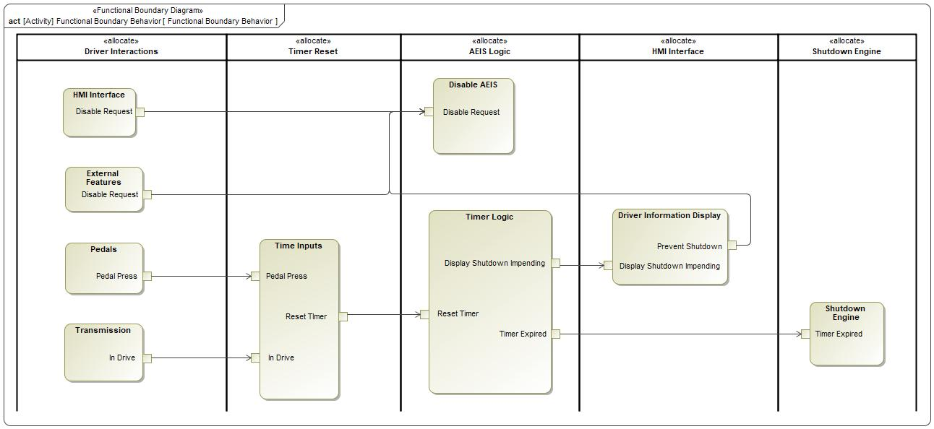

Figure 5: Functional Boundary Behavior

### List of Functions

**#Hint:** The functions shown in the Functional Architecture should be listed and described in the table below

| **Function Name** | Description | Comments |
| --- | --- | --- |
| *(action)* Disable AEIS | *(action)* The Feature has been disabled either by the driver or by another feature that requires extended idling |  |
| *(action)* Driver Information Display | *(action)* Displays a message to the driver warching of an impending engine shutdown, providing the option to prevent the shutdown and disable the Feature for the rest of the keycycle |  |
| *(action)* External Features | *(action)* There are other features that require extended idling so are able to request AEIS to be disabled |  |
| *(action)* HMI Interface | *(action)* The Driver can disable AEIS through the vehicle settings |  |
| *(action)* Pedals | *(action)* Any pedal interaction resets the AEIS Timer - effectively disabling the feature  When none of the pedals are being pressed then the timer will increment |  |
| *(action)* Shutdown Engine | *(action)* The engine will be shutdown after the timer expires |  |
| *(action)* Time Inputs |  |  |
| *(action)* Timer Logic | *(action)* The main Feature Logic.  The Timer will count up to a specified value, display an impending shutdown message and then shutdown the engine |  |
| *(action)* Transmission | *(action)* The transmission must be Park or Neutral or the timer will be reset |  |

Table 13: List of Functions

## Logical Architecture

**#Classification:** Functional Safety Analysis only

**#Hint:** FS Analysis requires a description of the boundary of the feature and its elements. A simple block diagram or a SysML Internal Block Diagram could be used to depict the Logical Architecture

***#Link:*** [*Ford Functional Safety Sharepoint*](https://pd3.spt.ford.com/sites/GlobalFunctionalSafety/Pages/default.aspx)

Description of diagram and content on logical architecture in Documentation field of Structural Boundary Diagram.

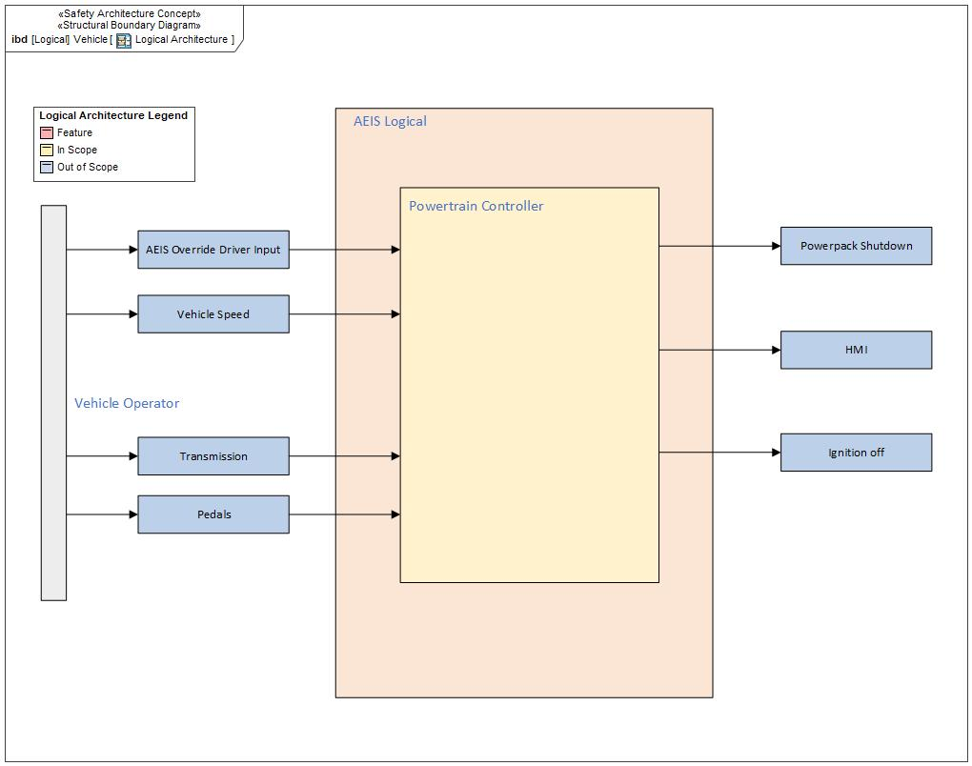

Figure 6: Logical Architecture

### Logical Elements

**#Hint:** Lists the elements of the Logical Architecture and the functions from the Functional Architecture, which are allocated to those elements.

No Logical Elements specified.

### Logical Interfaces

**#Hint:** Describe the interactions of the feature with other features or elements.

# Open Concerns

**#Hint:** The following list presents open concerns, which have to be discussed or clarified over the course of the on-going requirements engineering.

| ID | Concern Description | e-Tracker / Reference | Responsible | Status | Solution |
| --- | --- | --- | --- | --- | --- |
| 1 |  |  |  |  |  |

Table 14: Open Concerns *(Not supported by MagicDraw report generation)*

# Revision History

**#Hint:** A new version number is assigned to a document with a given revision each time it is checked in to Team Center (TCSE). After release of a revision, the document cannot be edited and no new versions can be created on that revision. When updating the document after that, a new revision has to be created and new versions on that revision will be created upon checking in.

No Revision History found.

## Template Revisions

*#Important: Do not change this section*

|  |  |  |  |  |
| --- | --- | --- | --- | --- |
| Version | Rev. | Date | Description | Responsible |
| *0* | *6* | *2015-05-26* | * *Chapter “Feature Overview” and made a 2nd level heading.* * *Chapter “Feature Modeling” divided into 3 subchapter (“Scenarios”, “Use Cases”, “State Machines”) for different modeling methods* | *Jbaden1* |
| *0* | *7* | *2015-05-27* | * *Table of Content updated* * *Template Revision History chapter added* | *Jbaden1* |
| *0* | *8* | *2015-07-02* | * *Section “Unsettled Issues” added* | *Alevin7* |
| *0* | *9* | *2015-08-04* | * *Section “Feature Variants” added* * *Section “Feature Boundary Diagram” renamed to “Feature Context Diagram”* * *Document Properties adapted to match needs of VBA macros* | *Jbaden1, Awegman1* |
| *1* | *0* | *2015-09-11* | * *Section “Feature Variants” reworked* * *Feature Goals removed. Only “Safety Goals“ chapter remains.* * *Heading 2 formatting issues corrected.* * *Requirements / Use Cases Listing removed from traceability chapter.* * *Formatting of attribute table in Notation chapter corrected* * *Open Topics / Known Issues chapter moved to the end* | *Jbaden1* |
| *1* | *1* | *2015-11-16* | * *Table-Styles removed (for smooth VSEM import)* * *Some clean-up of sections “Purpose” and “Audience”* | *Awegman1, jbaden1* |
| *1* | *2* | *2016-02-26* | * *Minor corrections based on lessons learned from CC and PCL pilot (e.g. section market/regions) and discussion with Functional Safety Team (purpose of feature)* * *Footer corrected* * *Boundary diagram interface chapter renamed to influences.* | *Jbaden1* |
| *1* | *3* | *2016-02-26* | * *Minor corrections after review with Whitney Keith from Functional Safety team* | *Jbaden1* |
| *1* | *4* | *2016-03-10* | * *Some cleanup of meta-data in Word Properties* | *Jbaden1* |
| *1* | *5* | *2016-03-10* | * *Footer formatting corrected (Issue 19)* * *Results from review with Functional Safety Team incorporated (Issue 20).* | *jbaden1* |
| *1* | *6* | *2016-04-18* | * *Scenario Template added* | *Jbaden1* |
| *1* | *7* | *2016-04-18* | * *Chapter “Operation Modes and States” moved before “Use Case” section.* | *Jbaden1* |
| *1* | *8* | *2016-04-18* | * *Broken Wiki links repaired.* | *Jbaden1* |
| *2* | *0* | *2016-05-19* | * *Adapted to Specification_Macros.dotm V2.0* * *Requirements Templates chapter (ch. 1.7.1) no longer has an attribute table, but refers directly to the Wiki..* | *Jbaden1* |
| *2* | *1* | *2016-06-10* | * *Table for Context Diagram modified (lists external entities and Influence Description only)* | *Jbaden1* |
| *2* | *2* | *2016-07-08* | * *Template version added to footer* * *Several hints added to the various sections* * *Findings from Functional Safety Team incorporated.* * *RE_SafetyRequirement style added* | *Jbaden1* |
| *2* | *3* | *2016-09-21* | * *Update from Functional Safety Team incorporated (“Lessons Learned”, “System Behaviors for HARA”)* | *Jbaden1* |
| *2* | *4* | *2016-11-15* | * *Update from Functional Safety Team incorporated (“Lessons Learned”, “System Behaviors for HARA”)* * *Explanatory notes made more formal* | *Jbaden1* |
| *3* |  |  | *Skipped to synchronize with Specification_Macros.dotm* |  |
| *4* |  |
| *5* | *0* | *2017-01-13* | * *Meta data updated for specification macros, version 3.1* * *SW Unit chapter removed for the time being* * *Green boxes added for user hints* | *Jbaden1* |
| *5* | *1* | *2017-01-18* | * *Minor editorial changes* | *Jbaden1* |
| *6* | *0* | *2017-02-03* | * *CR48: Chapter 6 renamed from “Safety” to “Functional Safety”. New sub-chapter “Safety” introduced in Non-Functional Requirements section* | *Jbaden1* |
| *6* | *0* | *2017-04-28* | * *CR7: “RequirementsTraceability” chapter removed* | *Jbaden1* |
| *6* | *0* | *2017-11-15* | * *CR32/53: New Cover Sheet + Disclaimer replaces FAP-150 like ones.* * *CR75: Some rewording -> Terminology to Glossary, Notation -> Document Conventions* * *CR49: Rename “Assumptions & Constraints” to “Assumptions”* * *CR74: Safety Assumptions added to chapter 6.* * *CR58: Add function allocation column to Logical Architecture chapter* | *Jbaden1* |
| *6* | *0* | *2018-01-31* | * *CR63: Updated links to Functional Safety Sharepoint* | *Jbaden1* |
| *6* | *0* | *2018-07-24* | * *CR69: Add FSR to FeatureDoc* * *CR64: Add new section "Design Requirements" to Function Spec and Feature Spec* | *Jbaden1* |
| *6* | *0* | *2018-08-06* | * *CR53: some corrections for metada and formatting* | *Jbaden1* |
| *6* | *0* | *2018-09-28* | * *Broken links to RE Wiki repaired* | *Jbaden1* |
| *6* | *0* | *2018-10-31* | * *Cover sheet and footer more GIS like. Functional Safety team feedback incorporated:*   + *New subsections “Functional Safety Requirements, (Decomposed) FSRs and Parameters / Values*   + *Removal of “Logical Architecture”* | *Jbaden1* |
| *6* | *0* | *2018-12-12* | * *FSR template removed, now as a macro in the Specification_Macros.dotm* | *Jbaden1* |
| *N* |  | *2019-04-03* | * *Updated code for context diagrams, actors and use cases.* * *Updated code structure with all macros at the beginning.* * *Updated code to populate assumptions using element-assumption relationship or hazardous event.* | *snuesch* |
| *N* |  | *2019-04-18* | * *Added structural boundary diagram for FuSa based on TGB discussion.* * *Added operating modes to functional safety requirements.* | *snuesch* |
| *N* |  | *2019-04-25* | * *Improved export of actions and activities on functional boundary diagram.* | *snuesch* |
| *6* | *0b* | *2019-05-23* | * *Re-introduce “Logical Architecture” (for Functional Safety)* | *Jbaden1* |
| *N* |  | *2019-06-17* | * *Aligned “Architecture” section with RE template.* * *Made “Ford Documents” table more flexible.* * *Added template terms to glossary* | *snuesch* |
| *N* |  | *2019-06-25* | * *Improved use cases to handle Primary and Secondary actors.* * *Added Performance Requirements to Uncategorized.* | *snuesch* |
| *6* | *0b* | *2019-06-26* | * *Chapter “Logical Elements” in “Logical Architecture” section added (FuSa CR 15136240)* * *“References” and “Glossary” chapter moved from section “Feature Overview” to “Introduction”. References and Glossary should be available in the document as early as possible* | *Jbaden1* |
| *N* |  | *2019-07-25* | * *Added populated “Logical Elements” table and allocated functions.* * *Export documentation field of context diagram.* | *snuesch* |
| *N* |  | *2019-08-09* | * *Export documentation field of use case diagram.* * *Fixed bug in Feature Requirement Verification Method.* * *Simplified export of References without publisher.* | *snuesch* |
| *N* |  | *2019-08-21* | * *Improved glossary and acronym tables* | *snuesch* |
| *N* |  | *2019-08-28* | * *Fixed bug in populating title in header* | *snuesch* |
| *N* |  | *2019-09-16* | * *Updated bibliography export* | *snuesch* |
| *N* |  | *2019-09-27* | * *Updated export of Verification Method and Requirement Status for Feature Requirements and V&V Method for Functional Safety Requirements.* | *snuesch* |
| *O* |  | *2019-11-12* | * *Updated bibliography export to include URL.* * *Allow hardware element on context diagram.* * *labelTag variable can be used to filter revision history.* * *Added logical property element type to beplled in from structural boundary diagram.* | *snuesch* |

# Appendix

## Definitions

| **Definition** | **Description** |
| --- | --- |
| term | A representation of a Concept expressed in Natural Language. In the vocabulary of a Domain of Discourse a term enables common understanding of domain concepts. |

Table 15: Definitions used in this document

## Abbreviations

No acronyms specified.

Document ends here.